City of Hapeville

ADOPTED
ANNUAL OPERATING BUDGET

FISCAL YEAR 2015

City of Hapeville

Organization Chart
Judge

ELECTED OFFICIALS APPOINTED OFFICIALS
CITY JUDGE
MONICA EWING

BILL WERNER
CITY MANAGER

DALEY, KOSTER & LAVALLEE, LLC
CITY ATTORNEY

J. K. BOATWRIGHT & CO, P. C.
CITY AUDITOR

BILL JOHNSON
PLANNING & ZONING DIRECTOR

ALAN HALLMAN
MAYOR

ANN RAY
ADLERMAN AT LARGE

MICHAEL RANDMAN
COUNCILMAN AT LARGE

JOSH POWELL
COUNCILMAN WARD I

DIANE DEMMICK
COUNCILMAN WARD II

DEPARTMENT DIRECTORS

CITY CLERK JENNIFER ELKINS

CHIEF OF POLICE RICK GLAVOSEK

FIRE CHIEF TOM E. MORRIS, JR

CLERK OF THE COURT JENNY COLEY

INFORMATION TECHNOLOGY COREY DANIEL

PLANNING & ZONING (CONTRACT) BILL JOHNSTON

RECREATION TOD NICHOLS

FINANCE AND ACCOUNTING JIM SCHUSTER

COMMUNITY SERVICES LEE SUDDUTH

Executive Summary
Budget Management Plan 1
City of Hapeville
Budget FY 2014-2015
Table of Contents
Budget Guide 2
Budget Calendar 3
Budget Highlights 4-5
Budget Comparison by Fund 6

General Government Funds
General Fund
Major Revenues and Sources 7
Expenditures by Major Function 8
Expenditures by Service Group 9-10
Assessed Value of Taxable Property 11
Capital Projects Fund 12
Debt Service 13

General Government Expenditures
Mayor and Council 14
Administrative & Financial Services 16
Clerk of Council 19
Human Resources 22
Information Technology
Police Department 25
Code Enforcement and Animal Control 28
Fire and Rescue Department 30
Recreation Department 33
Economic Development 36
Main Street Program 40
Municipal Court 44
Planning and Zoning 46
Community Services Department 49
Parks, Grounds, and Buildings 51

Enterprise Funds
Water and Sewer 53
Solid Waste 55

Reference Information
Organization Chart 59
Definition 60
Acronyms 70

Line Items
Revenues and Expenditures 71

BUDGET FY 2014-15 MANAGEMENT PLAN

To: Honorable Mayor and Members of City Council
From: Bill Werner, City Manager
Subject: Transmittal Letter – 2015 Operating and Capital Budgets

I am pleased to report we have vibrancy all around the City. Porsche Cars North
America is in advanced stages of completing their headquarters. We are out to bid for
capital improvements including North Central Avenue and North Fulton Avenue
Streetscapes, extensive parking improvements, the renovation of both the Veteran’s
Memorial and of the Hapeville Performing Arts Center, and equipping the renovated Depot.
Of note, to propel this progress the City Council has retained David Burt to secure
commercial amenities and focus on the development of properties within the City. As
the national and regional economies improve, our long standing economic erosion is ending.

As for City operations, I am proud to say we are hitting on all cylinders. The spirit of
public service is alive and flourishing in Hapeville as we continue to improve our
responsiveness to the needs of the community. I am proud of our team and their
ownership of responsibilities and dedication to providing exemplary services to our
residents and visitors.

Financially, we have some challenges. The continued use of fund balance in the General
Fund highlights the need for us to review on a constant basis all the things we do and
how we do them. We are dedicated to this philosophy. All options must be looked at,
both the revenue and expenditures, to keep the City moving at its current, and hopefully,
enhanced pace in the future – 2016, 2017 and forward.

Additionally, we have finally settled our longstanding negotiation with the City of
Atlanta and have adjusted the sewerage rates to reflect this agreement. Bonds were
issued for the payment and at the time of this writing we are awaiting the final invoices.
Also, our Sanitation Fund will require a review as our current rates are not sufficient. We
will be discussing this during the course of budget hearings.

I appreciate your support in my ability to serve this community. I look forward to
hearings on this budget and its ensuing implementation.

~ Bill Werner

ADOPTED
ANNUAL OPERATING BUDGET

FISCAL YEAR 2015

PREFACE

BUDGET GUIDE
Budgetary and Financial Structure
The Annual Budget serves a dual purpose:
- As required by statute it is the financial plan for the upcoming fiscal year and is composed of revenues and expenditures, organized based on Funds, each having a separate balanced budget.
- Equally as important the Budget is also a managerial plan with a description of the programs and services to be provided, achievements, and Goals and Objectives as offered by the City’s Departments and agencies in a narrative Section.
- The Budget matches the necessary resources to the Management plan, thereby authorizing the planned activities and services.
Within each Fund Budget are the appropriations, or authorized uses of resources, necessary to carry out the mission of each department.

Operationally and financially the budget is organized on “fund” accounting:

General Fund: The General Fund is the primary operating fund that provides for legislative, managerial and administrative government services, such as Mayor and Council, Administrative and Financial Services, Human Resources, and Clerk of the Council. Service divisions include Municipal Court, Police and Fire Protection, Code Enforcement, Recreation, Parks, Grounds and Buildings, Planning and Zoning, Economic and Community Development, and Highway and Streets Maintenance. Each service is organized by functional categories, departments, and appropriations.

Enterprise Fund: The City maintains two enterprise funds, the Water Sewer fund and the Solid Waste fund. These funds’ activities include all aspects of establishing, operating and maintaining the water sewer system and costs associated with solid waste operations. Costs are the basis for charges to the customers. Expenses have been summarized by class of expenditure: personal, contracted services, capital outlays, supplies, and debt service.

Capital Projects Fund The Capital Projects Fund accounts for the current capital projects and the respective funding sources.

Special Revenue Fund The Special Revenue accounts for revenues which are legally restricted as to use, and the respective expenditures thereof. Hotel Motel taxes are by far the major special revenue.

Department: Sub-classified under major function, the major organizational unit of the City generally charged with attaining the goals and objectives of the City.

Line Item Detail: This section serves as a reference for City department heads as to specific authorizations of personnel, supplies, capital equipment, etc. The section contains the “line item” detail of revenues and expenditures-the specific authorizations to expend City revenues.

BUDGET CALENDAR

Date Task

February, 2014 Distribute Budget Preparation Worksheets and instructions to Department Directors to prepare requested operating expenses

March, 2014 Prepare and distribute Personnel Worksheets and instructions to Directors requesting the necessary staffing and associated payroll and benefit costs.

April, 2014 Preliminary Personnel Worksheets returned to Finance Director

May, 2014 Preliminary Budget Worksheets returned to Finance Director

May, 2014 Compile Personnel Budget and compute fringe benefit costs

May, 2014 Load Personnel data to budget worksheets to computer budgeting module

May, 2014 Load Budget Worksheet data to computer budgeting module

May, 2014 Submit Preliminary Requested Budget to City Manager

June, 2014 City Manager and Finance Director conduct budget discussions with Department Heads

June, 2014 City Manager’s Proposed Budget Presentation to City Council

June, 2014 City Council discussions and public hearings to adopt final Budget

August, 2014 Property Tax Hearings

ADOPTED
ANNUAL OPERATING BUDGET

FISCAL YEAR 2015

FINANCIAL ANALYSES

BUDGET HIGHLIGHTS
FISCAL YEAR 2014-2015
FORMAT
The City uses "Funds" to account for its operations. A "fund" is a single entity, similar in
concept to a subsidiary of a corporation with its own asset , liability, revenue and expense
accounts.
"Appropriations" are authorizations to spend City revenues on the designated activities of
the City's Departments. The ANNUAL BUDGET applies only to the revenue and expense
accounts for the upcoming fiscal year ending June 30, 2015.

HIGHLIGHTS OF THE TOTAL BUDGET:
The total Annual Budget increased by 2.4%, including all Funds and operations.
The following table summarizes the City Budget by fund as proposed for Fiscal Year 2015 :

FISCAL YEAR 2014-2015
ANNUAL BUDGET: ALL FUNDS

 | 2011-2012 | 2012-2013 | 2013-14 | 2014-15 | % change
100-GENERAL FUND | 10,656,138 | 11,468,614 | 11,578,900 | 11,476,880 | -0.9%
201-SPECIAL REVENUE FUND | 1,139,926 | 1,189,498 | 2,148,875 | 2,120,138 | -1.3%
301-CAPITAL PROJECTS | 1,630,974 | 1,413,254 | 1,455,500 | 1,928,129 | 32.5%
505-WATER & SEWER FUND | 3,033,567 | 3,732,748 | 4,198,000 | 4,321,000 | 2.9%
540-SOLID WASTE FUND | 584,548 | 587,100 | 595,000 | 613,420 | 3.1%
TOTAL FY 2014 BUDGET | 17,045,159 | 18,391,214 | 19,976,275 | 20,459,567 | 2.4%

The General (operating) Fund's authorizations have declined by 0.9%.
The Special Revenue Fund which decreased 1.3% includes all seven cents of the
Hotel/Motel taxes as required by State law. Three cents is transferred to the General Fund
and four cents to HATT for Economic Development or Capital Projects
The Capital Projects Fund increased 32.5% with the addition of a major new project, a
$900,000 North Central Avenue Streetscape Project funded partly with a $720,000 grant.
The Water and Sewer Fund increased slightly as supply and distribution costs increased.
The Solid Waste Fund increased by 3.1% but will require a rate increase.
GENERAL FUND
For the General Fund, the approved tax digest projects a 2% rise in taxable values, before
appeals. Last year appeals reduced preliminary revenues by $100,000 or more.
The historic drop in taxable values has not shown any significant recovery.
State law requires the inclusion of “toxic mortgage” properties in the annual reassessments and
in the appeals process, thus further aggravating the decline in appraised and taxable value.
Other Financing Sources reflects the recordation of Hotel / Motel revenues as a transfer from
the Special Revenue Fund. Virtually all other revenue estimates remain the same.

General Fund Expenditures have declined by 0.9% as previous authorizations were revalued
and by the use of such “trimming” as only partially funding vacant positions.

SPECIAL REVENUE FUND
The Special Revenue Fund is used to account for the Hotel/Motel taxes and other restricted
revenues. The Fund will transfer $1,152.936 in Hotel/Motel tax to HATT (the Trade and
Tourism Authority) and $864,702 to the General Fund. Also included are small grants and
911 expenditures.

CAPITAL PROJECTS FUND

The expenses for some of the Capital Projects were incurred in Fiscal 2013-2014 and the remainder
are funded in the proposed budget:
Project List

 |  | 2013-2014 | 2014-2015 | Grants
Depot TE Project |  | 285,185 | - | -
North Central Ave Streetscape |  | 39,838 | 900,000 | 720,000
Access Road Earmark |  | 150,000 | 155,000 | 124,000
Dogwood-North Avenue |  | 146,000 | 60,000 | 48,000
R/R Construction |  | 250,000 | 181,000 | 181,000
North Fulton TE |  | 426,415 | 455,000 | 364,000
CDBG Sidewalks |  | 108,062 | 80,000 | 80,000
DOT-LMIG Program |  | 50,000 | 75,690 | 75,690
Total |  | 1,455,500 | 1,906,690 | 1,592,690

Most projects are grant-funded requiring a 20%-30% match provided by City funds, usually HaTT
Hotel/Motel taxes. Some projects are fully funded with State aid.

WATER & SEWER FUND

This Fund is financed through service charges. Recent rate increases make revenue forecasting
difficult. Settlement with the City of Atlanta for prior capital and operating expenditures remains open but Memoranda of Understanding have progressed for both capital and operations costs.

SOLID WASTE FUND

The Solid Waste Fund provides for solid waste pick-up and disposal. Historically rates have
not fully funded operations and a transfer of $75,000 from other funds was necessary in 2014.
However, for FY 2015 a rate increase will be required to cover operating costs.

.



 |  |  | ANNUAL OPERATING BUDGET: ALL FUNDS
 | PECENTAGE CHANGE |  | FY 2013-2014 |  | FY 2014-2015 |  | %
 | PER FUND |  | BUDGET |  | BUDGET |  | Change
 | General Fund |  | $11,578,901 |  | $11,476,880 |  | -0.9%
 | Special Revenue |  | 2,148,875 |  | 2,120,138 |  | -1.3%
 | Capital Projects |  | 1,455,500 |  | 1,928,129 |  | 32.5%
 | Water & Sewer |  | 4,198,000 |  | 4,321,000 |  | 2.9%
 | Solid Waste |  | 595,000 |  | 613,420 |  | 3.1%
 | Total Budget |  | $19,976,276 |  | $20,459,567 |  | 2.4%
 | General Fund | -0.90%
 | Special Revenue | -1.30%
 | Water & Sewer | 2.90%
 | Solid Waste | 3.10%

ADOPTED
ANNUAL OPERATING BUDGET

GENERAL FUND

The General Fund is the general operating fund
which includes the operation and maintenance all major services
except utilities.

General Fund
SUMMARY OF MAJOR REVENUES
 | FY 2012-2013 | FY 2013-2014 | FY 2014-2015 | %
 | BUDGET | BUDGET | BUDGET | CHANGE
Taxes | $ 8,580,900 | $ 8,510,500 | $ 7,872,900 | -7.5%
Licenses and Fees | 222,700 | 223,000 | 203,000 | -9.0%
Charges for Services | 1,327,135 | 1,091,549 | 1,108,341 | 1.5%
Fines and Forfeitures | 400,000 | 500,000 | 500,000 | 0.0%
Other Income | 236,200 | 25,500 | 35,600 | 39.6%
Other Financing Sources | 1,107,955 | 1,115,852 | 1,596,839 | 43.1%
Total Revenues | $ 11,874,890 | $ 11,466,401 | $ 11,316,680 | -1.3%
# Includes various interfund transactions, debt proceeds, etc
Taxes | 69.6%
Licenses and Fees | 1.8%
Charges for Services | 9.8%
Fines and Forfeitures | 4.4%
Other Income | 0.3%
Other Financing Sources | 14.1%

 |  | GENERAL FUND
EXPENDITURE BY MAJOR FUNCTION
 |  | FY 2012-2013 | FY 2013-2014 | FY 2014-2015 | Change
 | General Government | $ 1,920,026 | $ 1,784,113 | $ 1,992,450 | 11.7%
 | Judicial | 364,849 | 167,829 | 194,341 | 15.8%
 | Police Administration | 3,489,104 | 3,564,180 | 3,062,496 | -14.1%
 | Fire Administration | 2,917,334 | 2,605,355 | 2,783,440 | 6.8%
 | Community Services | 1,834,795 | 1,753,471 | 1,643,059 | -6.3%
 | Participant Recreation | 563,890 | 591,254 | 559,813 | -5.3%
 | Development and Planning | 784,892 | 1,000,199 | 1,081,081 | 8.1%
 | Total Expenditures | $ 11,874,890 | 11,466,401 | $ 11,316,680 | -1.3%

 |  | GENERAL FUND
 |  | EXPENDITURES BY ORGANIZATIONAL UNIT
 |  |  |  | 2012-2013 |  |  | 2013-14 |  |  | 2014-15 |  |  | %
 |  |  |  | BUDGET |  |  | REQUESTED |  |  | REQUESTED |  |  | Change
LEGISLATIVE
 |  | CITY COUNCIL |  | 35,736 |  |  | 36,736 |  |  | 131,586 |  |  | 258.2%
 |  | MAYOR |  | 12,043 |  |  | 18,793 |  |  | 19,043 |  |  | 1.3%
 |  | ELECTIONS |  | - |  |  | 8,928 |  |  | 500 |  |  | -94.4%
 |  | CITY CLERK |  | 107,948 |  |  | 100,242 |  |  | 98,037 |  |  | -2.2%
FINANCE & ADMINISTRATION
 |  | FINANCE & ADMINISTRATION |  | 1,581,578 |  |  | 1,018,168 |  |  | 878,729 |  |  | -13.7%
 |  | LEGAL SERVICES |  | 160,000 |  |  | 170,000 |  |  | 155,000 |  |  | -8.8%
 |  | INFORMATION TECHNOLOGY |  | - |  |  | - |  |  | 409,359
 |  | HUMAN RESOURCES |  | 163,221 |  |  | 356,246 |  |  | 289,196 |  |  | -18.8%
POLICE ADMINISTRATION |  |  |  | 3,304,447 |  |  | 3,395,701 |  |  | 2,917,858 |  |  | -14.1%
 |  | MUNICIPAL COURT |  | 204,849 |  |  | 167,829 |  |  | 194,341 |  |  | 15.8%
 |  | INSPECTIONS |  | - |  |  | - |  |  | -
 |  | CODE ENFORCEMENT |  | 184,657 |  |  | 168,479 |  |  | 144,638 |  |  | -14.2%
FIRE ADMINISTRATION |  |  |  | 2,917,334 |  |  | 2,605,355 |  |  | 2,783,440 |  |  | 6.8%
PARTICIPANT RECREATION |  |  |  | 563,890 |  |  | 591,254 |  |  | 559,813 |  |  | -5.3%
COMMUNITY SEVICES
 |  | HIGHWAY AND STREETS |  | 968,656 |  |  | 907,932 |  |  | 789,768 |  |  | -13.0%
 |  | PARK AREAS & GROUNDS |  | 866,139 |  |  | 845,539 |  |  | 853,291 |  |  | 0.9%
PLANNING & ECONOMIC DEVELOPMENT
 |  | PLANNING & ZONING |  | 89,000 |  |  | 90,000 |  |  | 87,250 |  |  | -3.1%
 |  | ECONOMIC DEVELOPEMENT |  | 664,392 |  |  | 870,199 |  |  | 953,831 |  |  | 9.6%
 |  | MAIN STREET |  | 51,000 |  |  | 40,000 |  |  | 40,000 |  |  | 0.0%
INTERFUND TRANSACTIONS |  |  |  | - |  |  | 75,000 |  |  | 11,000 |  |  | -85.3%
 |  | TOTAL: EXPENDITURES |  | 11,874,890 |  |  | 11,466,401 |  |  | 11,316,680 |  |  | -1.3%
 |  | EXPENDITURES BY MAJOR ORGANIZATIONAL UNIT
 |  | 6-03-2013 0 |  | 2012-2013 |  | 2013-14 |  |  | 2014-15
 |  | MAY 31ST, 2013 |  | BUDGET |  | REQUESTED |  |  | REQUESTED
LEGISLATIVE |  |  |  | 155,727 |  | 164,699 |  |  | 249,166
FINANCE & ADMINISTRATION |  |  |  | 1,904,799 |  | 1,544,414 |  |  | 1,732,284
POLICE ADMINISTRATION |  |  |  | 3,693,953 |  | 3,732,009 |  |  | 3,256,837
FIRE ADMINISTRATION |  |  |  | 2,917,334 |  | 2,605,355 |  |  | 2,783,440
PARTICIPANT RECREATION |  |  |  | 563,890 |  | 591,254 |  |  | 559,813
COMMUNITY SEVICES |  |  |  | 1,834,795 |  | 1,753,471 |  |  | 1,643,059
PLANNING & ECONOMIC DEVLOPMNT |  |  |  | 804,392 |  | 1,000,199 |  |  | 1,081,081
INTERFUND TRANSACTIONS |  |  |  | - |  | 75,000 |  |  | 11,000
 |  | TOTAL |  | 11,874,890 |  | 11,466,401 |  |  | 11,316,680
 | GENERAL FUND: PROPERTY TAXES
 | ASSESSED VALUE OF TAXABLE PROPERTY
 |  |  |  |  |  |  |  |  |  |  |  | %
 |  |  | FY 2012-13 |  | FY 2013-14 |  |  | FY 2014-15 |  |  |  | Total
 | Residential Property |  | $ 39,722,520 |  | $ 41,617,080 |  |  | $ 46,151,350 |  |  |  | 17.25%
 | Commercial Real Property |  | 149,074,650 |  | 145,358,690 |  |  | 149,120,850 |  |  |  | 55.74%
 | Commercial Personal Property |  | 64,110,140 |  | 57,379,520 |  |  | 50,234,410 |  |  |  | 18.78%
 | Industrial Property |  | 3,709,280 |  | 4,295,200 |  |  | 9,342,080 |  |  |  | 3.49%
 | Public Utility |  | 6,958,930 |  | 6,895,880 |  |  | 5,585,087 |  |  |  | 2.09%
 | Motor Vehicle |  | 8,258,170 |  | 8,426,420 |  |  | 7,102,350 |  |  |  | 2.65%
 | Total Taxable Property |  | $271,833,690 |  | $ 263,972,790 |  |  | $ 267,536,127 |  |  |  | 100.00%

FY 2015 BUDGET
SPECIAL REVENUE FUND

The Special Revenue Fund accounts for
revenues legally restricted to specific uses.
In particular this fund records and disburses
the Hotel Motel Tax

 |  | 201-SPECIAL REVENUE FUNDS
 |  | MAJOR CLASS | 2012-2013 | 2013-2014 | 2014-2015
 |  | REVENUE SUMMARY
 |  | BY CLASS OF REVENUE
 |  | MAJOR CLASS
 |  | TAXES | 1,732,002 | 1,988,875 | 2,017,638
 |  | LICENSES AND PERMITS | 0 | 0 | 0
 |  | INTERGOVERNMENTAL REVENUE | 38,887 | 5,000 | 0
 |  | CHARGES FOR SERVICES | 65,709 | 145,000 | 102,500
 |  | FINES AND FORFIETURES | 0 | 0 | 0
 |  | INVESTMENT INCOME | 0 | 0 | 0
 |  | CONTRIBUTIONS | 0 | 0 | 0
 |  | MISC REVENUE | 0 | 0 | 0
 |  | OTHER FINANCING SOURCES | 0 | 10,000 | 0
 |  | TOTAL REVENUES | 1,836,598 | 2,148,875 | 2,120,138
 |  | EXPENDITURES SUMMARY
 |  | BY CLASS OF EXPENDITURE
 |  | MAJOR CLASS
 |  | PERSONAL SERVICES | 0 | 0 | 0
 |  | CONTRACTED SERVICES | 0 | 0 | 0
 |  | SUPPLIES | 0 | 0 | 0
 |  | CAPITAL OUTLAYS | 0 | 0 | 0
 |  | OTHER COSTS | 0 | 0 | 0
 |  | DEBT SERVICE | 0 | 0 | 0
 |  | OTHER FINANCING COSTS | 1,848,068 | 2,148,875 | 2,120,138
 |  | TOTAL EXPENDITURES | 1,848,068 | 2,148,875 | 2,120,138
 |  | REVENUE OVER/(UNDER) EXPENDITURES | (11,470) | - | -

FY 2015 BUDGET
CAPITAL PROJECTS

The Capital Projects Fund accounts for major
capital improvements and the related financing sources.
In addition to grants the Fund receives Hotel Motel
Tax from the Hapeville Association for Trade and Tourism
via the Special Revenue Fund.

 | CAPITAL PROJECTS FUND
 |  | Budget | HATT | Budget | HATT
 | PROJECTS | FY 2013-2014 | FUNDED | FY 2014-2015 | FUNDED
 | Depot TE Project | 285,185 | $ 77,000 | - | -
 | No Central Ave Streetscape | 39,838 | 15,968 | 900,000 | 180,000
 | Access Road Earmark | 150,000 | 30,000 | 155,000 | 31,000
 | Dogwood-North Avenue | 146,000 | 109,200 | 60,000 | 12,000
 | R/R Construction | 250,000 | - | 181,000 | -
 | North Fulton TE | 426,415 | - | 455,000 | 91,000
 | CDBG Sidewalks | 108,062 | 85,283 | 80,000 | -
 | DOT-LMIG Program | 50,000 | - | 75,690 | 22,707
 | I-75 LOGO Project | - | - | - | -
 | Marta Station Improvements | - | - | - | -
 | Christ Church Relocation | - | - | - | -
 | Virginia Avenue/Doug Davis TE | - | - | - | -
 | WiFi Improvements | - | - | 21,439 | 21,439
 | Bike & Pedestrian Path | - | - | - | -
 | Total Capital Projects | $ 1,455,500 | $ 317,451 | 1,928,129 | 358,146

MANAGEMENT PLAN

Organizational Budget Narratives

Department Goals and Objectives

Mayor and Council:

Statement of Service:

The City of Hapeville operates under

the Council-Manager form of government whereby the Council establishes the vision and policy of the City and the City Manager is responsible for implementation. The Council consists of the Mayor and four Council members. The Mayor and Council represent the interests of the citizens of Hapeville by establishing the City’s direction, its range of services, and the mileage rate.
ELECTED OFFICIALS

Honorable Mayor
Alan Hallman

Alderman at Large
Ann Ray

Councilman at Large
Michael Randman

Councilman (1st Ward)
Josh Powell

Councilman (2nd Ward)
Dianne Dimmick

Mayor and Council:

OVERVIEW

The affairs of the City are conducted by a Mayor and Council, which consists of five members.
Under the City’s Charter, all corporate powers are vested in the Mayor and the Council members.

TERMS AND WARDS

The Mayor and Council Members serve four-year staggered terms in office. The City is divided
into two wards, and two at large seats; however, the Council Members are elected by the
voters Citywide.

ABOUT THE MAYOR

The Mayor is the Chief Executive Officer of the City. The Mayor presides at the Council
meetings and casts a vote only in the case of a tie.

VISION

- Provide for the Financial Health/Soundness of the City of Hapeville
- Ensure an effective and efficient working environment for the City staff
- Monitor the future needs of our key stakeholders

Mayor and Council:

OVERVIEW

The affairs of the City are conducted by a Mayor and Council, which consists of five members.
Under the City’s Charter, all corporate powers are vested in the Mayor and the Council members.

TERMS AND WARDS

The Mayor and Council Members serve four-year staggered terms in office. The City is divided
into two wards, and two at large seats; however, the Council Members are elected by the
voters Citywide.

ABOUT THE MAYOR

The Mayor is the Chief Executive Officer of the City. The Mayor presides at the Council
meetings and casts a vote only in the case of a tie.

VISION

- Provide for the Financial Health/Soundness of the City of Hapeville
- Ensure an effective and efficient working environment for the City staff
- Monitor the future needs of our key stakeholders



Financial services:

Statement of Service:
Financial Services includes the City Manager, acting as the Chief Operating Officer, and the Department of Finance .

The City Manager is responsible for coordinating the
functions of the City in the delivery of services to the
citizens and businesses. Under the Council-Manager form of government, the City Manager is appointed by and reports to the Mayor and Council. The City Manager is charged with the enforcement of the ordinances of the City and the implementation of the vision the Mayor and Council have determined.

The Finance Director is responsible for all financial
accounting and reporting of the City. Accounting processes include safeguarding assets, utility and tax billing, payroll, cash receipting, and cash disbursements. Reporting processes includes the annual financial report, the annual budget, special reports to governmental agencies, and monthly reports.

Administrative and Financial Services: City Manager
ACCOMPLISHMENTS FOR FISCAL YEAR 2013-14- City Manager
- Moved forward with GDOT and Norfolk Southern with $2,900,000 grant for pedestrian and vehicular safety improvements.
- Continued to search out and secure intergovernmental assistance consistent with the goals of City Council.
- Finalized engineering phase for Dogwood Drive (N. Central to North Ave.), N. Central Avenue (from Dearborn Plaza to Myrtle Street) and Loop Road access (Union, Atlanta, and Rainey) streetscapes and City Hall/Memorial Garden beautifications.

OBJECTIVES FOR FISCAL YEAR 2013-14- City Manager
- Finalize engineering phase for Dogwood Drive (N. Central to North to North Ave.), N. Central Avenue (from Dearborn Plaza to Myrtle Street) and Loop Road access (Union, Atlanta, and Rainey) streetscapes and City Hall/Memorial Garden beautifications.
- Support senior management in the continued constant improvement in the delivery of services.
- Continue to secure all intergovernmental financial assistance consistent with the goals of the City Council.
- Continue to enhance the safety, cleanliness, beauty and walkability of the City.
- Proceed on Federally Funded North Central and North Fulton Avenue streetscapes which includes City Hall and veterans memorial and with bond financing City Hall and Dearborn Plaza parking and alleyway.

Administrative and Financial Services: Finance and Accounting
ACCOMPLISHMENTS FOR FISCAL YEAR 2013-14 – Finance Department
- Revised allocation methods for Retirement costs and Health Insurance Costs
- Prepared Pro forma Comprehensive Annual Financial Budget in Excel shell
- Started earlier on Fiscal Year 2013 year-end preparation with an earlier closing of the City’s books
- Brought general ledgers and reporting system current
- Reviewed all bank accounts to determine necessity and change authorizations
- Brought all delinquent State DCA and DoAA required reports current
- Completed Annual Financial Report for FY 2013
- Submitted 2013 Annual Financial Report in time to meet State deadline
- Maintained budget Amendments for FY 2014
- Prepared Operating, HDA and HATT reports
- Revising HDA and HATT accounting methods
- Supported FY 2015 Bond Issue
- Billing and collection of Occupational Licenses, Property Taxes and Water & Sewer Charges
- Tied into Property Tax Digest via internet to track appeals and valuations
- Billed adjustments based on Assessment Appeal results
- Extended effort to collect delinquent property taxes and revaluations produced over $200,000
- Generated approximately 4,000 paychecks and processed about 48,000 billings and payments
- Improved skill levels with recruitment of Chief Accountant and training of existing staff
- Prepare Fiscal 2015 Annual Budget
- Create and load Personnel and Fringe Benefit costs worksheet for departments budgeting
- Generate and circulate operating and capital Budget Preparation Worksheets to departments
- Support for various issues- citizen complaints, special programs, etc
- Compile composite of debt service requirements

OBJECTIVES FOR FISCAL YEAR 2014-15 – Finance Department
- Cross training of employees for the various accounting and billing activities
- More timely and systematic accounting and reporting
- Monthly reconciliation of accounts
- Improved documentation of transactions and retention of electronic and physical files
- Smoother interface between the General fund, HaTT and HDA
- Earlier close for fiscal year end
- Standardization of journal entries
- Improve supporting documentation and schedules for annual audit
- Develop appropriate forms to document transaction processing

- Completion and GFOA award for Comprehensive Annual Financial Report
- Timely completion and submission of Interim and Annual Financial Reports
- Compile Financial Policies
- Improvement of internal controls
- Proper authorization of all transactions
- Continue mailing all payments to vendors and employees
- Improve Payroll/General Ledger interface
- Improve budget maintenance process
- Investigate drop box system for utility and tax payments.
- Research purchasing system and controls such as “p-cards”
- Research Project Accounting

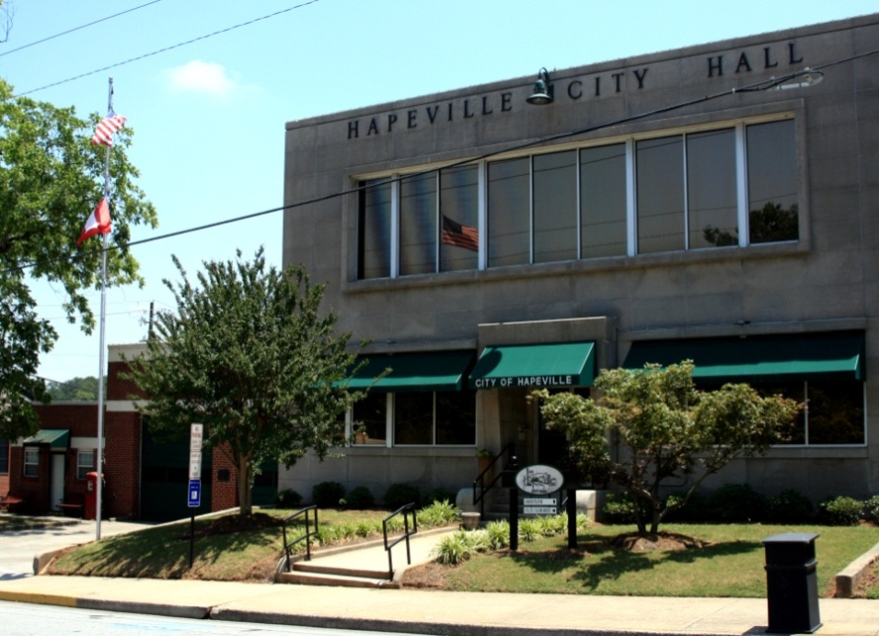
Clerk of the Council

clerk of the

council:

Statement of Service:
To uphold public trust, protect local
democracy, and provide access to matters of public interest diversely and inclusively by managing elections and annexations, preparing agendas and meeting notices, maintaining accurate Council record, and processing liquor and regulatory licenses.

ACCOMPLISHMENTS FOR FISCAL YEAR 2013-14
- Provided support to the following Boards and Committees: Mayor and Council, Alcohol Review Board, Ethics Committee, and Hapeville Development Authority
- Processed Open Records Request
- Maintained/Received credits for City Clerk certification
- Maintained training requirements for Elections Qualifications
- Codified the City of Hapeville Code of Ordinances
- Processed E-Verify and SAVE reports
- Processed Alcohol Beverage Licenses
- Processed Occupational Tax Permits

OBJECTIVES FOR FISCAL YEAR 2014-15
- Continue Document Shredding Program
- Continue training to maintain City Clerk’s Certification
- Continue organizing the City’s Permanent Files
- Codify the Code of Ordinances
- Update City website

Legal Services

The City Attorney is appointed by the City Council and is responsible for all legal matters of the City. The City may also employ special council on select matters.



human resources:

Statement of Service:

The Human Resources Department
works as a team to provide effective
service and vital information to
employees, retirees, and the public
with compassion, dignity, and
respect in a fair and equitable
manner. Human Resources is
responsible for recruitment, testing,
employment, compensation, benefits,
health and safety, training and
development, collective bargaining
and labor-management relations,
classification, placement, and
records.

Human Resources:

ACCOMPLISHMENTS FOR FISCAL YEAR 2013-14

- Safety Committee
- Conducted Open Enrollment for all Full-time Employees and Retirees
- Processed applications and conducted interviews
- Provided Compensation Statements to Employees
- Implemented online enrollment for Employee benefits
- Maintained Retiree Insurance Payments

OBJECTIVES FOR FISCAL YEAR 2014-15
- Improve Employee Morale
  - Host employee events during the year
    - Possibly ice cream day, pizza night, car wash, etc.
- Host at least one quarterly training through the Safety Committee
- Implementation of Supervisor’s Training Program
- Review and recommend amendments to the Employee Handbook
- Review and recommend timekeeping practices
- Continue organization of Personnel files – research possible conversion to electronic personnel files
- Create a Benefit Guide
- Update City Website

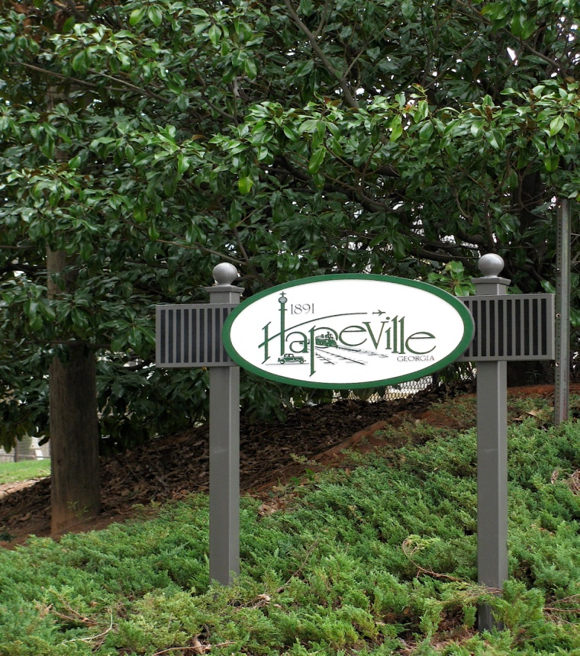
Information Technology:

information

technology:

Statement of Service:

IT and Communications Internal
Services Fund is responsible for the
technology planning and technical
support of hardware and software
for all City Departments. The IT
and Communications Fund also
handles all expenditures relating to
information technology related
infrastructure including Public
Safety hardware and software. The
maintenance and management of the
City of Hapeville Website and the
Hapeville Wireless Network falls
under this fund as well.

ACCOMPLISHMENTS FOR FISCAL YEAR 2013-14
- Spillman Server upgrade and Migration successful.
- Sharp Signage Software Implemented and Information screens. Also replaced all old copiers
- Court Services Department was successfully moved from City Hall to Police Department.
- Finance Department:
- Successfully implemented the City’s Web-Tax Digest on the City Website (View Only).
- Incode: Upgraded our Financial and Tax Management System (Version 9).
- Online Payment convenience fee added to the City Website.
- Fire Department Training Room build-out in City Hall which includes flat screen, projector & Screen, surround sound, pc setup, network connectivity.
- Cisco IOS upgrade of Switches and Routers City-Wide.
- City Computers were replaced on an as-needed basis.
OBJECTIVES FOR FISCAL YEAR 2014-15
- Unified Communication upgrade of the phone system which. The cost range is $ 35,000 - 45,000.
- Unitrends: Backup Appliance upgrade to backup employees’ computers, restore Desktop computers or Servers & offsite storage of the City’ most critical data. Model RC813 or 822 -$18,000 - $23,000.
- City Wide Surveillance Camera System: Researching companies for better service of the city camera system.

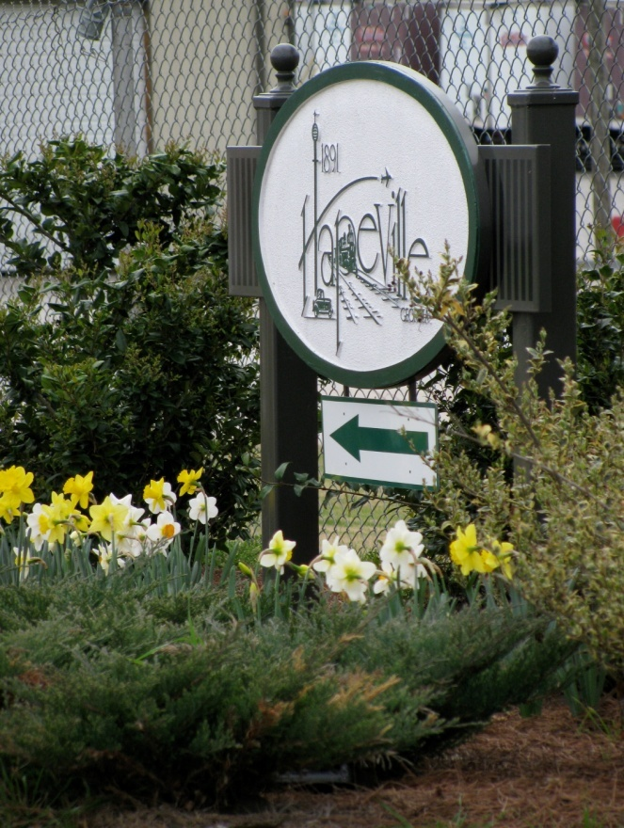
Municipal Court Services:

Municipal Court

Services:

Statement of Service:

The City of Hapeville Municipal

Court is dedicated to the

administration of justice through procedures established by the Judicial and State legislature ensuring all matters before the Court are resolved expeditiously, equitable and without bias. We have created and will maintain a professional environment where efficient and knowledgeable service will be provided in a courteous and timely matter to all who seek our assistance.

ACCOMPLISHMENTS FOR FISCAL YEAR 2013-14
- Municipal Court Services has filled the vacancy of Assistant Court Clerk/Receptionist. This staff member will serve in two (2) areas, working in the Reception area as well as assist in Court Services.
- Court Services processed 4616 traffic and general copy citations for the calendar year 2013
- Court Services has continued to review legislation to remain in current compliance
- State mandated Municipal Court Clerk training obtained for the Clerk of Court & the Court Administrator
- Court Services has worked on updating court related files and filing delinquent dispositions.
- Court Services has provided a professional and prompt environment in a courteous and timely manner

OBJECTIVES FOR FISCAL YEAR 2014-15
- Court Services will continue to review ongoing legislation to remain in compliance
- Court Services will continue to promptly process all traffic citations, parking tickets and warnings
- Court Services will continue to complete and electronically file dispositions promptly, in compliance with DDS requirements
- Update all court related files and begin purging, pursuant to the Court Retention schedule
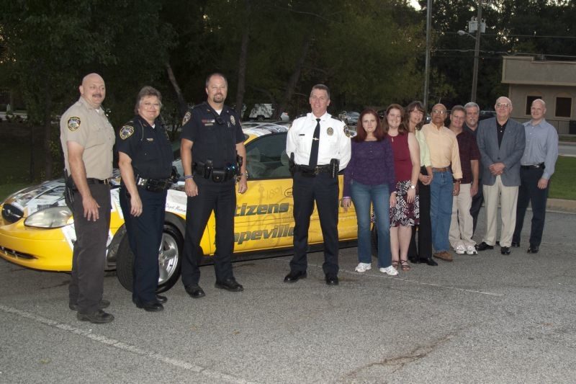

police administration:

Statement of Service:
The mission of the Police Administration is to consistently seek and incorporate ways to promote, preserve and deliver quality security and safety services to our community, while maintaining the highest of integrity.
We will continue to provide a high quality of police
service by developing and maintaining a partnership with the community.

The Administrative Division strives to promote quality
performance from all members of the department by
incorporating transparency and accountability in a
consistent manner. All members of the department are included in planning and managing of community
activities to be active within the community.

Police Administration:

ACCOMPLISHMENTS FOR FISCAL YEAR 2013-14
- The Department handled 6131 service calls and 3693 traffic incidents for a total of 9824 incident
- The Police Department maintained an average response time of 3 minutes
- The Police Department has implemented a program called CompStat, which uses computer aided statistics and mapping to help identify crime trends and locations
- The Police Department successfully filled several vacancies and continues to recruit high quality employees on an as-needed basis
- The Police Department successfully completed the recertification of the State Certification
- The Police Department is diligently working on reaching the standards for CALEA
- The Police Department has continued to incorporate community policing, as well as provide safety for all residents. Programs to include:

- Safetyville for the children
- Citizens Police Academy
- Citizens on Patrol
- Attendance at Neighborhood Watch Programs
- Attend school functions and be visible and increase visibility within the community

Police Administration:

OBJECTIVES FOR FISCAL YEAR 2014-15
- Our goals for this next year include the continued growth and development of our current programs that include:
- The Citizen Police Academy
- Citizen on Patrol
- Safetyville
- We will work on adding programming with a focus on older teens, possibly a sports mentorship.
- We will continue to develop and maintain our CompStat program, in an effort to stay in front of crime by understanding trends.
- We will continue to develop our community oriented policing efforts to ensure a strong collaboration between the department and the community. This will include, attendance at neighborhood meetings and events, training more bike patrol officers, more GEM Car patrolling and increased foot patrols
- We will continue to work on reducing crime through special operations such as, Bait Car deployment, Traffic Safety Checks and Specialized Drug Enforcement.
- We will continue to maintain our State of Georgia Certification and work to achieve an International Accreditation.

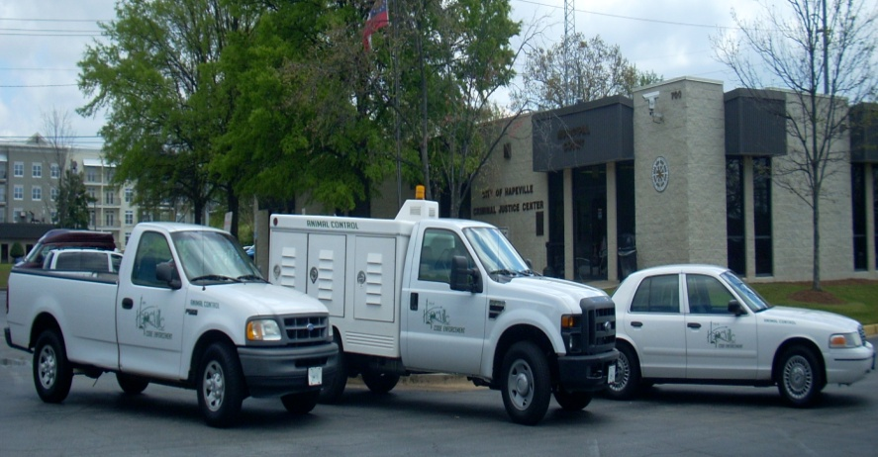

CODE ENFORCEMENT:

Statement of Service

The mission of the Code Enforcement &
Animal Control Division is to perform
technical level work ensuring that all
relevant codes and ordinances are
adhered to throughout the City, as well as
apprehending and transporting animals
found in violation of animal control
ordinances. The mission of the Code
Enforcement & Animal Control
Department shall always be accomplished
in a professional manner.

Code Enforcement:

ACCOMPLISHMENTS FOR FISCAL YEAR 2013-2014

- Code Enforcement/Animal Control personnel handled approximately 2171 cases with 578 related to animal control and 1593 related to Code violations.
- Code Enforcement/Animal Control personnel issued 102 citations.
- Code Enforcement/Animal Control personnel have continued to provide the citizens with professional and prompt service, while they work in a courteous and timely manner.
OBJECTIVES FOR FISCAL YEAR 2014-2015

- Code Enforcement/Animal Control personnel will continue to answer and respond to all emergency and non-emergency phone calls made related to code violations and animals at large, which include apprehension of such animals.
- Code Enforcement/Animal Control personnel will respond and assist citizens in a friendly and professional manner.
- Code Enforcement will educate citizens about the city codes and work with them to promote compliance and beautification throughout city.
- Code Enforcement/Animal Control personnel will inspect all code violations and issue citations when necessary.
- Code Enforcement/Animal Control personnel will continue to ensure that all related services are handled in a professional manner.

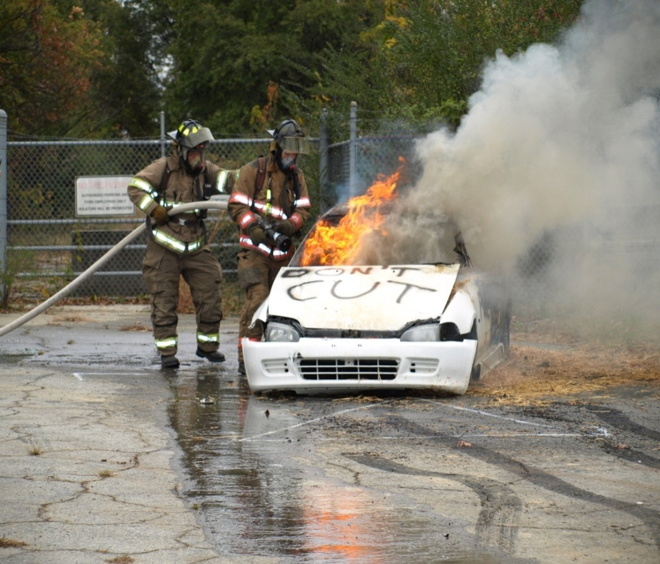
Fire and Rescue Department:

Fire and rescue:

Statement of Service:

The mission of the Fire Department is to provide professionally trained,
competent, and ethical
firefighters to preserve life and
property within the City of
Hapeville. The Fire Department’s principle function is to provide services such as: fire suppression,
emergency medical service, fire
prevention, public education,
decontamination of hazardous materials decontamination, and City-wide emergency management
coordination.

ACCOMPLISHMENTS FOR FISCAL YEAR 2013-14

- Collected money for Georgia Firefighters Burn Foundation, MDA, and Toys for Kids program
- Maintain a rating of 3 from the Insurance Services Office (ISO)
- Suppression personnel completed 193 pre-incident plans
- Remodeled the bathroom located in the sleeping quarters at Station #2
- We responded to 1,454 calls in 2013 with an average response time of 02:16 minutes
- Our ALS ambulance transported 735 patients to numerous hospitals throughout the Metro Atlanta Area.
- Responded to 319 fire related incidents in 2013
- Firefighters collected money through boot drives for the Georgia Burn Foundation, the Toy for Kids
program, and Muscular Dystrophy Association (MDA)
- We trained 17 citizens through 2 (CERT) Citizens Emergency Response Team classes
- Fire Department personnel completed over 8,900 hours of training in 2013
- We hosted 2 courses Basic Disaster Life Support and Advanced Disaster Life Support
These courses were instructed by Emory University and the Georgia Department of Public Health
We had 8 members complete the BDLS course and 4 completed the ADLS course

Fire and Rescue Department:
ACCOMPLISHMENTS FOR FISCAL YEAR 2013-14 (Continued)
- During 2013 the department obtained two “acquired structures” to utilize for live fire training exercises
- The following training was conducted over numerous days at both structures
  - All suppression personnel completed Search and Rescue training,
  - 8 members completed Rapid Egress from a Hostile Environment and Rapid Intervention Team Drills,
  - 21 personnel participated in “live fire” training
- Two firefighters completed the National Pro Board Certification in Public Fire and Life Safety Educator
- Three of our EMS instructors recertified their instructorships in Advanced Cardiac Life Support
and Pediatric Advance Life Support

OBJECTIVES FOR FISCAL YEAR 2014-15

- Maintain Response Times; optimize customer satisfaction
- Conduct another CERT class this summer and one in the spring
- Implement Career Matrix for Fire Department
- Send 10 more personnel through Atlanta’s Flashover Simulator
- Complete replacement of turnout gear for suppression personnel
- Replace outdated rope equipment
- Purchase 10 new radios
- Continue working towards International Fire Accreditation
- Replace 2 computers

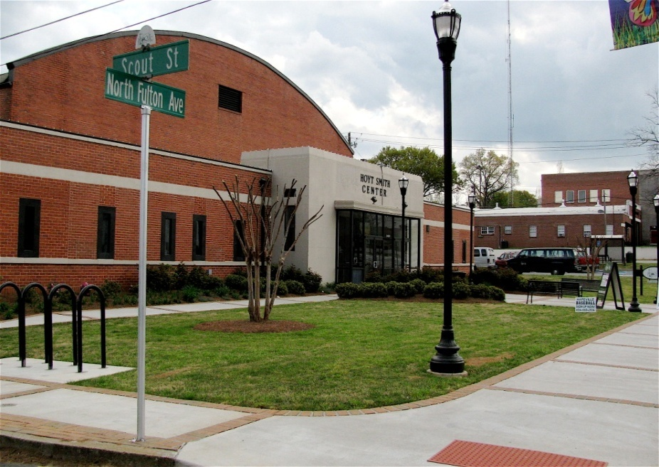

recreation

department:

Statement of Service:

To offer diversified and efficient
recreational programs and activities
that build self esteem, develop
positive character and provide
physical, mental and social benefits to
our youth, adults and senior citizens .
that enrich their quality of life and to
maintain and prepare our facilities in a
clean, safe and enjoyable environment
for the citizens of Hapeville.

Recreation Department:

OBJECTIVES FOR FISCAL YEAR 2014-15

- Continue to promote a spirit of cooperation, build self-esteem, motivate healthy competition and develop lifelong recreational interests among all program participants
- Develop recreational options that meet the needs of the community through various granting programs.
- Continuing the efforts of becoming a world-class community center by providing those who live in, work in and visit Hapeville the opportunity to participate in a multiplicity of leisure experience in both group and individual settings
- Establish the Hapeville Parks & Recreation Department as a recognized leader in our community, theState and the nation through responsive, effective programming and excellence in park and
recreation management
Seek professional development for Director in all aspects of municipal government and continue to grow all parks and recreation personnel
- Continue to promote and require attendance of management personnel to attend state and national conferences to keep up with certifications and industry initiatives
- Continue to work with Public Works, Fire and Police Departments to enhance, promote and protect our park facilities

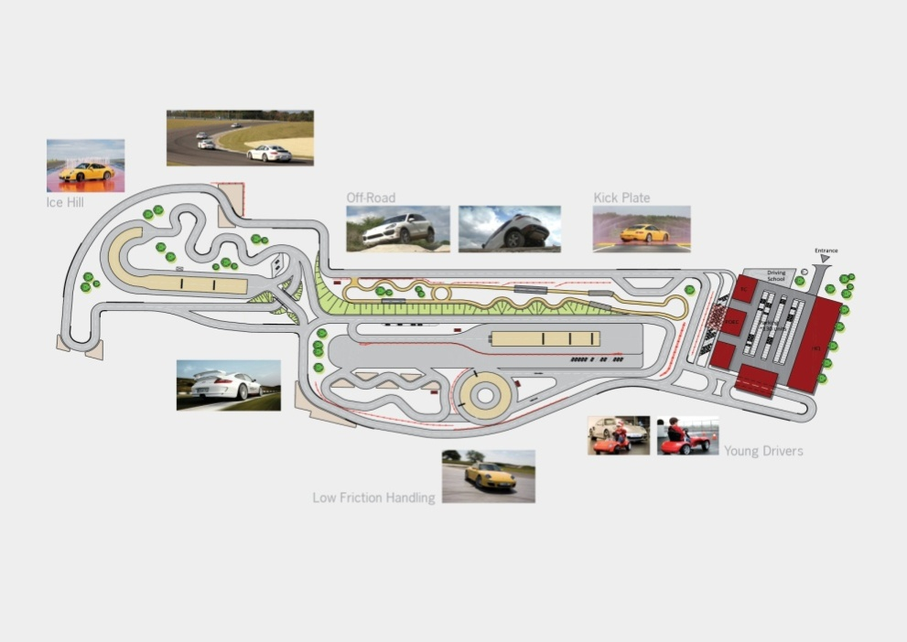

economic

development:

Statement of Service:

The mission of Economic
Development is to stimulate
and manage the revitalization
efforts of the community, both
economically and culturally by
encouraging and facilitating
investment. The City’s goal is to
position itself as a regional
model for a vibrant urban
community.

Porsche Test Track

Economic Development Department:

ACCOMPLISHMENTS FOR FISCAL YEAR 2013-14
- Blue Print 2020 was completed and presented to City Council. Continued on-going initiatives therein. Future action item prioritization in-progress with City Council
- Maintained Opportunity Zone Designation and leveraged job tax credit incentive program with businesses
- Researched regional efforts making initial investment in creation of Community Improvement District
- Expanded on efforts for the promotion of Economic Development activities and services to the greater community
- Researched and developed a comprehensive list of state incentives, funding/incentive programs, and real estate tools to City website to make economic development resources easily accessible
- Represented the City at local and regional business functions. Produced City presentations, including creating the City’s first digital State of the City Address in a visual/presentation format
- Continued business retention and recruitment efforts: including City tours, informational visits and communications (retention focus group: hotels)
- Issued RFQ for Branding and Marketing Campaign
- Managed Christ Church operations and events
- Coordinated Planning and Zoning activities including: handling initial inquiries, agenda preparation, conducting research, and public meeting assistance. (See Planning & Zoning for further information.)
- Achieved “New Classic Main Street” designation by the Department of Community Affairs. Managed Main Street Program (See Main Street for further information.)

ACCOMPLISHMENTS FOR FISCAL YEAR 2014-15 (Continued)
- Produced and managed City Special Events (12 total) including festivals (2), concert series (4), movie nights (4), and special holiday events (2). Continued developing and new policies and procedures for event participation with standardized on-line forms and increasing on-line event promotions.
- Awarded South Arts Film Series Grant. Produced and managed South Arts Independent Film Series Events (6) as per HATT agreement.
- Assisted with coordinating promotions and/or activities for Hapeville sponsored events/entities including: Hapeville Performing Arts Center/Academy Theatre, Car Event Series, Paint the Town, Tri-Cities Run, and Exchange Club 5K.
- Continued staff professional development initiatives. Focus areas included: communications: peer-to-peer inter-departmental website training; and Economic Development: Department of Community Affairs downtown specific trainings—awarded scholarship as senior program manager to audit the GA Cities Foundation Mobile Bus Tour Workshop.

OBJECTIVES FOR FISCAL YEAR 2014-15
- Continue implementing Blue Print 2020 initiatives as per City Council
- Contract with Economic Development Consultant to implement certain objectives of Blue Print 2020
- Conduct Branding and Marketing Study/ Manage implementation of recommendations to expand on community identity with community branding/marketing efforts
- Create recommendation for City Council to adopt a Community Events Sponsorship Program to encourage and improve partnerships, and to prioritize objectives
- Work with City Council to fund a limited Façade Improvement Program
- Continue to work with State Agencies and other resources to identify and promote incentive programs and other opportunities
- Continue assistance activities for major re-development projects as needed
- Continue to strive for excellence in downtown development elevate Hapeville’s Main Street Program standing amongst peer cities as an example of a progressive revitalization program. Continue business retention and recruitment efforts: including informational visits and communications. Develop “Open House” events for businesses
- Coordinate Planning and Zoning activities including: handling initial inquiries, agenda preparation, conducting research, and public meeting assistance.
- Manage Christ Church operations
- Maintain Website and Newsletter re: E.D. and Events Activities. Expand e-services and on-line resources, expand social media efforts
- Maintain training and professional development for staff as per recommendations from DCA including: IEDC Certification, event/facility management and public relations
- Produce City Special Events (12 total) including festivals (2), concert series (4), movie nights (4), and special holiday events (2)
- Produce South Arts Independent Film Series Events (6) as per HATT agreement



MAIN STREET:

Statement of Service:

The mission of the
Hapeville Main Street
Program is to promote,
facilitate, enhance, and
encourage quality growth
and development in
Downtown Hapeville
while preserving the
City’s historic character.

Main Street:

ACCOMPLISHMENTS FOR FISCAL YEAR 2013-14

- Maintained Focus on Design/Visible Improvements to Downtown through Projects Including:
- Hapeville “Celebrates the Arts” Mural installation in partnership with HATT
- Downtown Planter Program
- Initiated Historical Marker Program

- Fostered Business Friendly Environment through Programs and Communications Including:
- Increased communications with local businesses. Direct mailings included events information, and state incentives.
- On-site visits were conducted in conjunction with the Holiday Business Appreciation Program—materials distributed included Opportunity Zone Information, the availability of e-mail notifications.
- Continued Tri-Cities Merchants B-to-B Meeting/Event Series
- Participated in Downtown Revitalization Focused Events/Activities Including:
- Volunteers participated in HATT South Arts Film Series by assisting with film selections, and serving as ambassadors promoting the series on-line and hosting filmmakers and attendees.
- Increased Program Leadership Educational Opportunities: Manager and Volunteers participated in trainings offered by the Department of Community Affairs, a regional Main Street Downtown Revitalization 2-day Conference with courses and in a Mobile Bus Tour offered by the GA Cities Foundation.

Main Street:

OBJECTIVES FOR FISCAL YEAR 2014-15
- Focus on Design/Visible Improvements to Downtown through Projects Including:
- Public Art Initiatives: Complete Phase II Butterfly Project, Depot Plaza Project, and Pedestrian Bridge Project.
- Re-Evaluate Planter Program in concert with streetscape projects.
- Make Design Renderings obtained from DCA available as conceptuals for potential renovation projects.
- If funding is available, facilitate Façade Grant Program with Development Authority.
- Implement Historical Marker Program

- Continue Focus on Business Friendly Environment through Programs and Marketing Including:
- On-line/Social Media initiatives: & Program Outreach: Increase Downtown FB posts, Main Street Business program resources/communication.
- Tri-Cities Merchants B-to-B Meeting/Event Series

- Participate in Downtown Revitalization Focused Events Including:
- Cultural Activities: South Arts Film Series Volunteering
- Business Sustainability: Partnering with other community organizations to assist with downtown activities including Tri-Cities Merchants B-to-B Meeting/Event Series offering networking opportunities and educational presentations to businesses.
- Program Growth/Opportunity: Participation in National Main Street Conference, to be held in Atlanta and participation in trainings/conferences. Continue to grow the Program on the principals as set forth by the Department of Community Affairs.

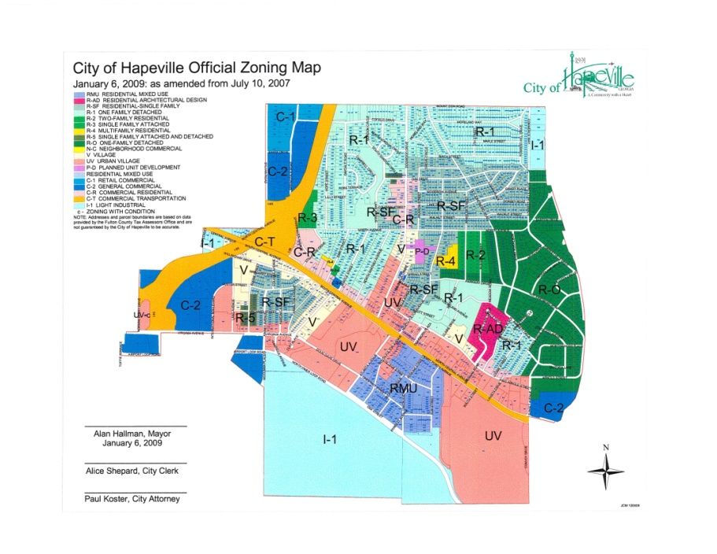

PLANNING AND ZONING:

Statement of Service:

The Planning & Zoning Division’s
mission is to help guide citizens and
developers through the processes of
development established by the
Mayor and City Council. The functions
of the department include
consultation on zoning and
development regulations,
administrative activities related to
development, long-range community
planning, economic prosperity, and
neighborhood stability.

Planning and Zoning:

ACCOMPLISHMENTS FOR FISCAL YEAR 2013-14
- Adoption of the following Ordinances:
  - Sign Ordinance, Mural Ordinance, Subdivision Regulations, Accessory Buildings Ordinance
  - Cultural Arts District Overlay
- Minor Plan Updates
  - Urban Redevelopment Plan
  - Comprehensive Plan and Future Development Map
- Major Plan and Ordinance Updates
  - Comprehensive Plan
  - Zoning Ordinance

OBJECTIVES FOR FISCAL YEAR 2014-15
- Broaden the Planner’s Role in the Aerotropolis Initiative
- Establish an Innovative Process for Soliciting Citizen, Area Employee and Business Owner Input
- Propose an Infill Housing Ordinance
- Organize and Build a GIS Data Base
  - Nonconforming Properties Data Base
  - Nonconforming Signs Data Base
  - Housing Conditions Data Base
- Adoption of the following Ordinances:
  - Free Libraries Ordinance
  - Vehicle Sales by Lending Institutions Ordinance
  - Outdoor Merchandize Display Ordinance
  - Places of Assembly Ordinance

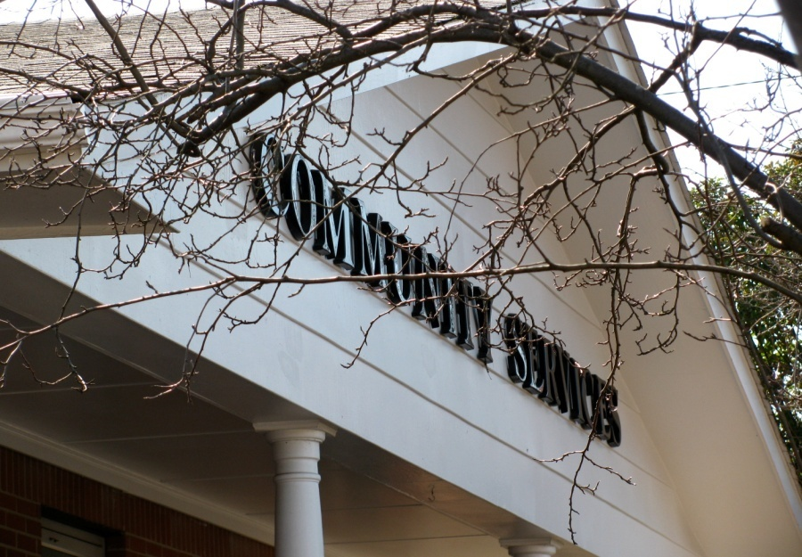
Community Service Department:

community service

department:

Statement of Service:

The Highways & Streets Division's
mission is to make sure our city
roads, traffic signs, traffic signals,
and street signs are functioning
properly and are in good working
condition. Other functions include
paving, curbing and sweeping of city
roads and the maintenance of
sidewalks.

ACCOMPLISHMENTS FOR FISCAL YEAR 2013-14

- Completed North Ave. CDBG Sidewalk Project
- Treated & Cleared Major Roads during 2 snow/ice storms
- Completed street sweeping on all streets

OBJECTIVES FOR FISCAL YEAR 2014-15

- N. Fulton Sidewalk Replacement( CDBG funds)
- Paving of selected roads (LMIG funds)
- Complete N. Central Avenue LCI Streetscape Project
- Complete N. Fulton “War Memorial” TE Project

The Community Services Department oversees Highways and Streets and Parks, Grounds and Facilities in the General Fund. The Department also oversees the operations of the Water and Sewer utility and Sanitation Services which are presented as separate independent funds which are financed from user charges.
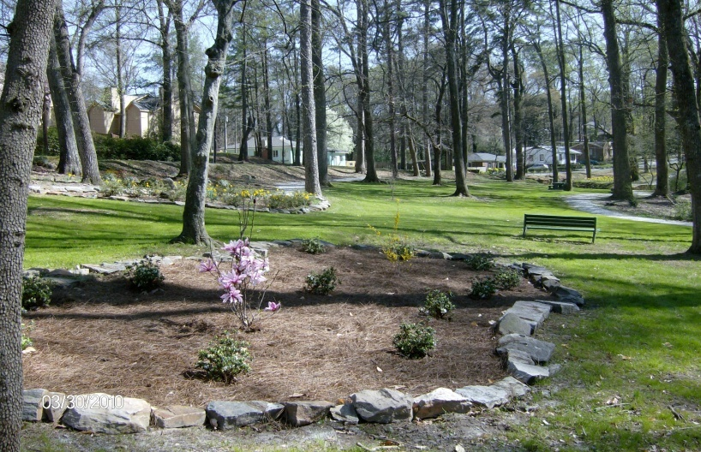

PARKS, GROUNDS & FACILITIES:

Statement of Service:

The Parks, Grounds & Facilities Division's
mission is to provide an area where Hapeville
citizens can enjoy athletic and leisure
activities. Functions include maintaining all
city parks, city buildings, railroad areas and
the Tom Morris Sports Complex. They also
provide staffing of city events and festivals.

Parks, Grounds and Facilities:

ACCOMPLISHMENTS FOR FISCAL YEAR 2013-14

- Painted all baseball fences black
- Painted and sealed Hoyt Smith gym floor
- Installed new energy efficient lighting in Community Services Department
- Installed new swing set at Cofield Park
- Completed Depot Renovation Project

OBJECTIVES FOR FISCAL YEAR 2014-15

- Complete renovation of 597 N. Central Building
- Reconfigure & Pave City parking lots and put City Hall utilities underground
- Pave railroad parking lots on S. Central Avenue

WATER & SEWER

Statement of Service:

The Water & Sewer Division’s mission is to
provide Hapeville’s citizens and customers
with clean, safe drinking water. To
maintain the distribution and collection
sewer systems in accordance with
accepted Federal and State standards.
Continue to be responsive and proactive to
the needs of the Community.

Water & Sewer:

ACCOMPLISHMENTS FOR FISCAL YEAR 2013-14

- Completed Water Loss Audit
- Completed Ms4 Storm Water Report
- Serviced All City Compound Meters
- Flushed All City Hydrants
- Negotiated Reduced Amount For Capital Sewer Billing
- Replaced 2 collapsed sewer lines

OBJECTIVES FOR FISCAL YEAR 2014-15

- Install Touch Read Meters on two streets
- Flush All City Hydrants
- Replace 2” waterlines on Hope Street, Dogwood Drive and Oak Drive
- Complete Ms4 Storm Water Report

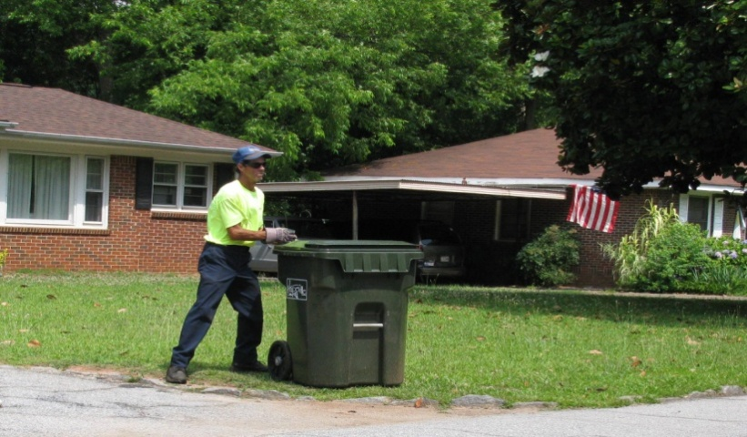
Solid Waste:

solid waste:

Statement of Service:

The Solid Waste Division’s mission is to
provide pickup of garbage, trash and yard
debris in an efficient manner. We also
provide recycling as a method of reducing
the amount of waste that goes into the
landfills.

ACCOMPLISHMENTS FOR FISCAL YEAR 2013-14

- Conducted Clean Sweep Program
- Recycled Tires in Atlanta
- Continued to compost all loose leaves

OBJECTIVES FOR FISCAL YEAR 2014-15

- Continue to make Solid Waste Fund self sufficient
- Expansion of composting program for leaves
- Apply for Green City Status

Definitions
The budget document contains specialized and technical terminology that is unique to public
finance and budgeting. The following definitions are provided to assist the reader in
understanding these terms.

Account Number: | A line item code defining an appropriation.
Accounting System: | The total structure of records and procedures which record, classify,  summarize and report information on the financial position and results  of operations of a government or any of its funds, fund types, balanced  account groups, or organizational components.
Accrual Accounting: | The method of accounting under which revenues are recorded in  the accounting period in which they are earned and expenses are  recognized in the period in which they are incurred.
Ad Valorem Tax: | Commonly referred to as property taxes. These charges are levied  on all real and certain personal property according to the  property’s assessed valuation and the tax rate.
Adopted Budget: | Term used to describe revenues and expenditures for the upcoming year beginning July 1st as adopted by City Council.
Advanced Refunding: | A transaction in which new debt is issued to provide monies to pay interest on old, outstanding debt as it becomes due; and to pay the principal on the old debt either as it matures or at an earlier call date.
Appraised Value: | The market value of real and personal property as of January 1st each year, determined by Fulton County Tax Commissioner Office.
Appropriation: | A specific amount of money authorized by City Council for the purpose of providing or acquiring goods and services.
Appropriation: | The formal statement approved by the City Council which shows budgeted revenues and Resolution: expenditures for the approaching fiscal year.
Assessed Property Value: | The value set upon real estate or other property by the Fulton County Assessor and the State as a basis for levying taxes. The assessed value in the state of Georgia is 40 percent of the fair market value.
Assets: | Property owned by a governmental unit which has monetary value.
Audit: | The examination of documents, records, reports, systems of internal control, accounting and financial procedures.
Authorized Position  Resolution: | The formal statement approved by the City Council that outlines the approved positions for the approaching fiscal year.
Balance Sheet: | A financial statement that discloses the assets, liabilities, reserves  and balances of a fund as of a specific date.
Balanced Budget: | A budget in which planned funds available equal planned  expenditures.
Bond: | A certificate of debt issued by an entity guaranteeing payment of  the original investment plus by a specified future date.
Bond Proceeds: | The money paid to the issuer by the purchaser of a new issue of municipal debt securities used to finance a project or purpose for which the securities were issued, and to pay certain costs of issuance as may be provided in the bond contract.
Bonded Indebtedness: | That portion of indebtedness represented by outstanding bonds.
Budget: | A financial plan for a specified period of time that matches all planned revenues and expenditures to planned services.
Budget Authority: | Under certain circumstances, the City Council may adjust budgeted appropriations for reasons unforeseen at the time of the adoption of the original budget. Such amendments are made by Council. The City Manager may make transfers of appropriations within a function.
Budget Calendar: | The schedule of key dates or milestones, which the City departments follow in the preparation, adoption and administration of the budget.
Budget Document: | The official publication that outlines the financial plan as approved by the City Council.
Budget Message: | A general discussion of the proposed budget as presented by the  City Manager to City Council.
Capital Outlay: | Expenditures which result in the acquisition of a fixed asset, such  as equipment, vehicles, building improvements or major repairs.
Capital Project Budget: | A financial plan for construction of physical assets such as buildings, streets, and recreation facilities.
Chart of Accounts: | The classification system used by the City to organize the accounting for various funds.
City Council: | The Mayor and four Council members collectively acting as the legislative and policymaking body of the City.
Comprehensive Annual  Financial Report (CAFR): | A report published to provide the Council, representatives of financial institutions, our citizens and other interested persons, detailed information concerning the financial condition of the City government.
Contractual Services: | The cost related to services performed for the City by individuals,  businesses or utilities.
Debt: | An obligation resulting from the borrowing of money or from the  purchase of goods and services.
Debt Limit: | The maximum amount of gross or net debt which is permitted by law.
Debt Service: | Interest and principal payments associated with the issuance of debt.
Deficit: | An excess of expenditures over revenues and resources.
Delinquent Taxes: | Taxes that remain unpaid 45 days after taxes are billed and to which a penalty for non-payment is attached.
Depreciation: | A decrease in value of physical assets due to use and the passage of time.
Effectiveness: | The degree to which a program or procedure is successful at  achieving its goals and objectives.
Efficiency: | The degree to which a program or procedure is successful at  achieving its goals and objectives with the least use of resources.
Encumbrance: | An amount of money committed for the payment of goods and  services not yet received or paid for.
Ending Fund Balance: | The excess of the fund’s assets and estimated revenues for the period over its liabilities, reserves and appropriations for the period.
Enterprise Fund: | A self-supporting fund designed to account for activities supported by user charges.
Equipment: | Tangible property of a permanent nature which is useful in  carrying on operations, such as machinery, tools, and furniture.
Estimated Revenue: | The amount of projected revenue to be collected during a fiscal year.
Excise Tax: | A levy on a specific type of transaction at a rate specific to that  transaction. Also known as a selective sales tax.
Expenditures: | Costs of goods received or services rendered.
Financial Policies: | Financial policies are used to enable the City to achieve a sound financial position. They are in writing and are periodically updated and endorsed.
Fiscal Year: | Any period of 12 consecutive months designated as the budget year. The City’s fiscal year begins on July 1st and ends on June 30th.
Fixed Assets: | Assets of long-term character, which are intended to continue to  be held or used, such as building, machinery and equipment.
Franchise Fees: | Fees paid to a municipality from a franchisee for the use of city streets and right-of-ways. Businesses required to pay franchise fees include utilities such as gas, electricity, cable television, and telephone.
Function: | A group of related activities aimed at accomplishing a major service or regulatory program.
Fund: | A set of interrelated accounts to record revenues and expenditures associated with a specific purpose.
Fund Balance: | The difference between a fund’s assets and its liabilities. Portions  of the fund balance may be reserved for various purposes.
Fund Group: | A group of funds which are similar in purpose and character.
General Fund: | A fund used to account for all transactions of a governmental unit  which are not accounted for in another fund.
General Obligation Bonds: | Bonds that finance a variety of public projects such as streets,  buildings, and improvements. The repayment of these bonds is  usually made from the general fund. These bonds are backed by  the full faith and credit of the issuing government.
Goal: | A statement of broad direction, purpose or intent based on the  needs of the community.
Government Accounting  Standards Board (GASB): | A standard-setting body, associated with the Financial Accounting  Foundation, which prescribes standard accounting practices for  governmental units.
Governmental Fund: | A fund used to account for mainly tax-supported activities.
Grant: | A contribution by a government or other organization to support  a particular project.
Infrastructure: | Facilities on which the continuance and growth of a community  depend, such as streets and roads, sewers, public buildings, and parks.
Interest Rate: | The annual yield earned on an investment, expressed as a  percentage.
Internal Service Fund: | A fund used to account for cost that is allocated to other funds  based on usage.
Interfund Transfers: | Amounts transferred from one fund to another.
Intergovernmental  Revenue: | Revenue received from another governmental entity for a  specified purpose.
Investments: | Securities and real estate held for the production of income in the  form of interest, dividends, or lease payments.
Lease Purchase: | Method of financing used for the acquisition of improvements. Title to the property transfers to the City at the expiration of the lease terms.
Legally Adopted Budget: | The total of the budget of each City fund including budgeted  transactions between funds.
Levy: | The total amount of taxes, special assessment or service charges  imposed by a governmental unit.
Liabilities: | Debt or other legal obligations arising out of transactions in the past which must be liquidated renewed or refunded at some future date.
Licenses and Permits: | Revenues in this category are charges designed to reimburse the  City for costs of regulating the activities being licensed.
Line Item Budget: | A budget that lists each expenditure category separately along  with the dollar amount budgeted for each specified category.
Local Option Sales Tax (LOST): | Tax levied at the rate of one percent which applies to the same  items as the State sales tax.
Long Term Debt: | Debt with a maturity of more than one year after the date of issuance.
Maintenance: | The upkeep of physical properties in condition for use or occupancy.
Millage Rate: | The ad valorem property tax rate expressed in terms of the levy per thousand dollars of taxable assessed value.
Modified Accrual  Accounting: | The basis of accounting under which expenditures are recorded as  soon as they result in liabilities for benefits received and revenue  is recorded when received. The extent of modification varies in  practice, depending upon the accountant’s judgment.
Net Assets: | The difference between the City’s total assets and total liabilities.  Measuring net assets is one way to gauge the City’s financial condition.
Net Bonded Debt: | Gross bonded debt less any cash or other assets available and earmarked for its retirement.
Net Budget: | The legally adopted budget less all interfund transactions. Interfund transactions representing transfers and interfund reimbursements are subtracted from the legally adopted budget amount to prevent being double counted from the perspective of the entire budget.
Object: | As used in expenditure classification, this term applies to item purchased. or the service obtained, such as personal services, purchased property services, other purchased services, supplies and capital outlay
Objective: | Serving as a goal; being the object of a course of action.
Occupational Tax Permit: | This is a general tax of business for the privilege of conducting  business within the city limits. Rates are set at each city’s  discretion but may not be discriminatory or confiscatory.
Ordinance: | A formal legislative enactment by the governing board of a municipality.
Overlapping Debt: | The proportionate share that residents, within the reporting government, must bear of the debts of other local governments located wholly or in part within the geographic boundaries of the reporting government.
Paying (Fiscal) Agent Fees: | Fees paid to the financial institution that receives and disburses  bond payments made on the City’s debt obligations.
Performance Measures: | Specific quantitative measures of work performed within a department.
Personal Property: | Mobile property not attached permanently to real estate, including tangible property such as furniture, equipment, inventory, and vehicles.
Personal Services: | The costs associated with compensating employees for their  labor. This includes salaries and fringe benefits.
Policy: | A set of guidelines used for making decisions.
Productivity: | A measure of the increase of service output of City programs compared to the per unit of resources input invested.
Projected: | Estimation of revenues and expenditures based on past trends,  current and expected economic conditions, and future financial forecasts.
Property Tax: | A tax levied on the assessed value of real, public utility, and  personal property.
Proprietary Fund: | A fund to account for activities that are often business like whether internal or external in operations.
Public Hearing: | The portions of open meetings held to present evidence and provide information on both sides of an issue.
Purchase Order: | A document which authorizes the delivery of specified merchandise or the rendering of specific services.
Real Property: | Immobile property; examples are land, natural resources above  and below the ground, and fixed improvements to the land.
Refunding: | The issuance of new debt whose proceeds are used to repay  previously issued debt.
Reserve: | An account used to record a portion of the fund balance as legally  segregated for a specific use, usually at a future time.
Resolution: | A special order of the City Council, which has a lower legal  standing than an ordinance.
Revenues: | Monies received or anticipated by a local government from both  tax and non-tax sources during the fiscal year.
Revenue Appropriation: | A designated portion of a fund allocated and appropriated in  order to meet potential liabilities during a fiscal year.
Revenue Bond: | Bond secured by the revenues of the specific operation being financed.
Service Level: | Measurement of services provided by the City to the public.
Special Revenue Fund: | A fund in which the revenues are designated for a specific purpose
Supplies: | Expenditures or expenses for supplies that ordinarily are consumed within a fiscal year and which are not included in inventories.
Tax Rate: | The amount of tax stated in terms of a unit of the tax base.
Taxes: | Compulsory charges levied by a government for the purpose of financing services performed for the common benefit. The term does not include specific charges made against particular persons or property for current or permanent benefits such as special assessments.
Transfers In/Out: | Amount transferred from one fund to another to assist in financing the services of the recipient fund.
Undesignated Fund  Balance: | Funds in excess of current needs and which the City Council has not specifically designated for any other purpose. The City maintains an undesignated general fund balance to help mitigate the effects of such unanticipated situations such as economic downturns, loss of revenues, additional costs imposed by other governmental entities or law suits, errors in financial forecasting, and natural disasters.
User Charges: | The payment of a fee for direct receipt of a public service by the  party benefiting from the service.
Workloads: | A measure of the services provided.

ACRONYMS

AED – Automatic Electronic Defibrillator
CAD – Computer Aided Dispatch
CAFR – Comprehensive Annual Financial Report
CALEA – Commission on Accreditation for Law Enforcement Agencies
CDBG – Community Development Block Grant
COPS – Community Oriented Policing Services
DEA – Drug Enforcement Agency
DOJ – Department of Justice
DOT – Department of Transportation
MIS – Management Information Systems
EPD – Environmental Protection Department
FTE – Full Time Equivalent
GCIC – Georgia Crime Information Center
GFOA – Government Finance Officers Association
GIS – Geographic Information System
GTA – Georgia Technology Authority
HATT – Hapeville Association of Trade and Tourism
HDA - Hapeville Development Authority
ICMA – International City/County Management Association
ISO – Insurance Services Office
IT - Information Technology
LAN – Local Area Network
LCI - Livable Centers Initiative
LOST - Local Option Sales Tax
MDT – Mobile Data Terminals
MS4 - Municipal Separate Storm Sewer Systems
NIMS- National Incident Management System
NOI – Notice of Intent
NPDES – National Pollutant Discharge Elimination System
POST – Peace Officers Standards and Training
TAD – Tax Allocation District

